Renewable Energy: Windmill Challenge

SC Academic Standards: 4.E.2B.1, 5.P.5A.1, 6.E.2B.1, 6.P.3A.1, 8.P.2A.1, 8.E.5C.1, H.B.6D.1 (Design solutions to reduce the impact of human activity on the biodiversity of an ecosystem).
NGSS DCI: 4,5-ESS3, 4-PS3, MS-HS-ESS3, 3-5, MS, HS- ETS1,
Science and Engineering Practices: S.1.A.3, S.1.A.4, S.1.A.5, S.1.A.6, S.1.A.8
Crosscutting Concepts: Cause and Effect: Mechanism and Explanation; Energy and Matter.
Focus Question(s): What number, shape, and/ or arrangement of blades on a windmill will produce the most power?

Conceptual Understanding:

Background: What are some forms (types) of energy that you can think of? What are some sources of energy? There are many types of energy including the chemical energy of food, thermal, or heat, energy, and the electrical energy you get when you plug in your computer. Much of the electricity in the United States is produced by burning coal, a non-renewable energy source. When coal is burned, the heat energy produced turns water into steam, and the steam runs through a turbine, which can generate electricity – thus the chemical energy of the coal is transformed into electric energy. The steam can be condensed back into water and re-used, but burning the coal makes a lot of pollution (from the acid coal tailings leftover at the mine, to the CO₂ produced by burning it, to the mercury impurities in the coal which, when burned, escape into the air. So, burning coal is polluting and causes climate change, and coal is non-renewable (we have a finite supply, and, once we run out it’s gone).
Renewable energy is much better if your goal is sustainability, especially with the threats we face if we don’t slow climate change. South Carolina is looking at the feasibility of an offshore wind farm, to capture wind energy. Windmills are the ancient ancestors of modern wind turbines. This lab exercise will help students understand how a windmill captures the energy of the wind and converts it into usable mechanical and electrical energy. The blades of a wind turbine have the most important job of any wind turbine component; they must capture the wind and convert it into usable mechanical energy. Over time, engineers have experimented with many different shapes, designs, materials, and numbers of blades to find which work best.

In this lab you will use the science and engineering design process to design, test, and modify a windmill.
Previous Knowledge (physics): Vocabulary words like torque and pitch and drag will be important here. Torque is a Force times a Distance that causes rotation. Think of it as the number of blades - the windmill blades act like a lever arm rotating around an axis - so blades with a greater surface area have greater torque when wind is applied to the blade. The more torque, the more weight those blades will lift. Thus, 6 blades will usually lift more weight than three. Pitch is essentially the angle of the blade with respect to the plane of rotation (blades perpendicular to the oncoming wind = 0º, blades parallel to the wind = 90º). A shallow pitch (say, 10-30º) spins faster but a greater pitch (30-60º) gives the windmill better torque so it lifts better. Usually blades pitched at 30-45º lift the most weight. To sum it up,
windmills designed with 3-6 sturdy blades pitched at an angle of 30-45º will lift the most weight.
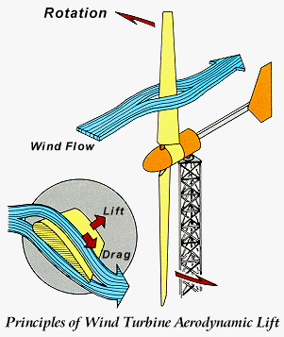
Blade
Reaction

Wind direction
Fan

Deflection

Drag (wind resistance) is also important – the friction of the blades against the air molecules as it rotates. Drag will slow down the windmill’s rotation. Last, the size and shape of the blades are important too – let the students explore variations on these, but suggest they focus on one variable at a time (larger blade versus smaller, oval shape versus rectangular versus triangular, etc.).

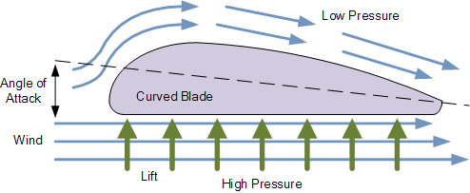
Most wind turbines designed for the production of electricity have consisted of a two or three bladed propeller rotating around a horizontal axis. Just like an airplane wing, wind turbine blades work by generating lift due to their curved shape. The side with the most curve generates low air pressure while
high pressure air beneath pushes on the other
side of the blade airfoil. The net result is a lift force
perpendicular to the direction of flow of the air.

Materials: Each group of 4 students needs:
Wooden dowel rods (various sizes), long nails or stiff wire (i.e. insulation holders), wooden skewers, straws, index cards, popsicle sticks, corks, straight pins, wire, clay, dixie cups, string, pipe cleaners, string, paperclips, twist-ties, hose or aquarium tubing pieces, scissors or wire cutters, about 20 pennies, tape, and one small fan.

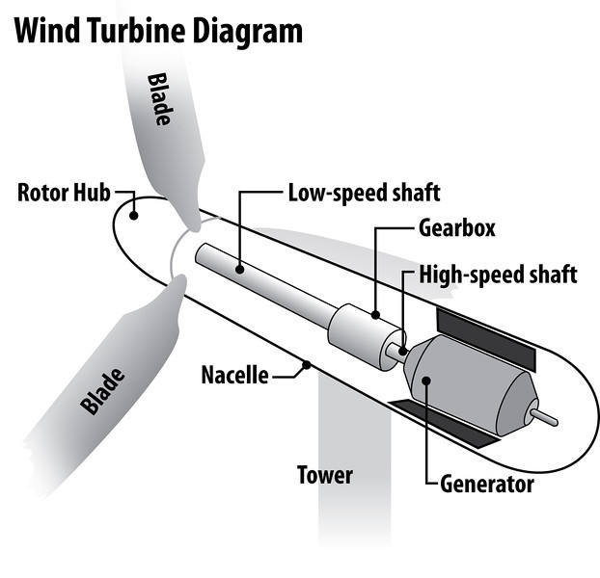
Procedure: Make a windmill whose blades will turn. You have 40 minutes.
Next, let’s test your windmill: To test the power of the wind turbine, you want to hang weight on the end of the driveshaft to see how much weight it can lift. Correctly assembled, when the blades turn from the fan's wind, it turns the hub, which turns the driveshaft, which pulls the string. The string wraps around the driveshaft lifting the weight (pennies in a cup). First, get your windmill to lift the empty cup, then add pennies in groups of 4 to the cup - the number you record is how many pennies your windmill can lift (all the way up).

Group | # pennies lifted
1
2
3
4
5
6

Table 1. Data on windmill’s power (ability to lift pennies)

Reflection Questions:

1. What form of energy gives a person the ability to run or jump? (Although there are many kinds of energy in the world, they all fall into two broad categories: potential energy and kinetic energy. When energy is stored up and waiting to do things, we call it potential energy; "potential" simply means the energy has the ability to do something useful later on. When stored energy is being used to do something, we call it kinetic energy; "kinetic" means movement and, generally, when stored energy is being used up, it is making things move or happen).
2. What form of energy powers the food chain? (Solar energy is the base of the food chain – plants take in solar energy and transform it into chemical energy (bonds of carbohydrates, lipids, proteins store energy) during the process of photosynthesis. Then, when a herbivore eats a plant, not only does the herbivore get the atoms /nutrients (the carbs, proteins, and lipids) but it also gets the energy. The energy stored in the chemical bonds of food is transformed into both heat and ATP energy (chemical bonds energy) in the process of cellular respiration. ATP energy can be used to do the body’s work – from making muscles work (energy of motion) to active transport to building proteins to powering flagella to acting as a messenger for nerve cells).
3. What form of energy produced the radiant energy plants need to make their own food? (All stars produce light (and other kinds of energy) through nuclear reactions, using the energy stored in the tiny nucleus at the center of atoms. These reactions make the star so hot that it glows -- it's like an enormous ball of fire, giving out light and heat).
4. List 3 non-renewable sources of energy: (coal, oil, natural gas, uranium).
5. List 3 renewable sources of energy: (wind, solar, geothermal, wave, hydroelectric, biomass, tidal, Hydrogen).
6. Which renewable energy source uses heat from underground? (geothermal).
7. What blade shape worked best on your windmill? (windmills designed with 3-6 sturdy blades pitched at an angle of 30-45º will lift the most weight).
  - How many blades?
  - How were the blades oriented?
  - What can you change to the blades (hub, driveshaft) to improve your design?

- How is friction affecting your results? (there will be friction wherever the driveshaft rubs against something else – like the driveshaft rubbing on the piece of tubing or straw that it goes through. This slows it down and reduces the weight it can lift).

- What might be reducing the ability of your turbine to perform at its best? (friction, weight of windmill parts).

- What other factors might be affecting the number of pennies you are able to lift?

11. In terms of the different windmills your classmates designed - which design worked best? (# blades, pitch of blades, shape of blades)?

SKETCH your Windmill Design HERE:

Bibliography:

Alternative Energy Tutorials. 2010. http://www.alternative-energy-tutorials.com/energy-articles/wind-turbine-blade-design.html
Accessed 9/20/15.

Darci J. Harland. (n.d.). Stem mom http://www.stemmom.org/2012/10/building-wind-turbines-engineering-lab.html Accessed 9/20/15.

Kidwind Project, Inc. 2015. Windwise Education www.windwiseeducation.org Accessed 9/20/15.

Orenda Energy Solutions. 2015. Aerodynamic design of a windmill http://orendaenergy.com/aerodynamic-design-of-a-wind-turbine-blade/ Accessed 9/20/15.

Student Handout

There are many types of energy including the chemical energy of food, thermal, or heat, energy, and the electrical energy you get when you plug in your computer. Much of the electricity in the United States is produced by burning coal, a non-renewable energy source. When coal is burned, the heat energy produced turns water into steam, and the steam runs through a turbine, which can generate electricity – thus the chemical energy of the coal is transformed into electric energy. The steam can be condensed back into water and re-used, but burning the coal makes a lot of pollution (from the acid coal tailings leftover at the mine, to the CO₂ produced by burning it, to the mercury impurities in the coal which, when burned, escape into the air. So, burning coal is polluting and causes climate change, and coal is non-renewable (we have a finite supply, and, once we run out it’s gone).
Renewable energy is much better if your goal is sustainability, especially with the threats we face if we don’t slow climate change. South Carolina is looking at the feasibility of an offshore wind farm, to capture wind energy. Windmills are the ancient ancestors of modern wind turbines. This lab exercise will help students understand how a windmill captures the energy of the wind and converts it into usable mechanical and electrical energy. The blades of a wind turbine have the most important job of any wind turbine component; they must capture the wind and convert it into usable mechanical energy. Over time, engineers have experimented with many different shapes, designs, materials, and numbers of blades to find which work best. In this lab you will use the science and engineering design process to design, test, and modify a windmill.

Procedure: Make a windmill whose blades will turn. You have 40 minutes.
Then, test the power of the wind turbine, by hanging weight on the end of the driveshaft to see how much weight it can lift. Correctly assembled, when the blades turn from the fan's wind, it turns the hub, which turns the driveshaft, which pulls the string. The string wraps around the driveshaft lifting the weight (pennies in a cup). First, get your windmill to lift the empty cup, then add pennies in groups of 4 to the cup - the number you record is how many pennies your windmill can lift (all the way up).

Group | # pennies lifted
1
2
3
4
5
6

Table 1. Data on windmill’s power (ability to lift pennies)

What blade shape worked best on your windmill?
How many blades?
How were the blades oriented?
What can you change to the blades (hub, driveshaft) to improve your design?
How is friction affecting your results?
What might be reducing the ability of your turbine to perform at its best?
What other factors might be affecting the number of pennies you are able to lift?
In terms of the different windmills you and your classmates designed - which group’s design worked best? (# blades, pitch of blades, shape of blades)?

SKETCH your Windmill Design HERE:

